Learning Report – Applied SDLC and Software Testing

./



### Document History

|  |  |  |  |  |  |
| --- | --- | --- | --- | --- | --- |
| **Ver. Rel. No.** | **Release Date** | **Prepared. By** | **Reviewed By** | **Approved By** | **Remarks/Revision Details** |
|  |  | Binitta Michael |  |  |  |
|  |  |  |  |  |  |
|  |  |  |  |  |  |
|  |  |  |  |  |  |
|  |  |  |  |  |  |

TASK 1- MINIPROJECT 4

**1.INTRODUCTION 4**

**2.REQUIREMENTS 4**

* 1. **High Level Requirements 4**

**2.2Low Level Requirements 4**

**3.UML DIAGRAM 5**

**3.1UsecaseDiagram………………………………………………………………………..………….....5**

* 1. **Class Diagram…………………………………………………………………………………….…6**

**3.3Flow Chart……………………………………………………………………………………..........7**

**3.4Package Diagram…………………………………………………………………………………...8**

**4.TEST PLAN…………………………………………………………………………………………..….9**

**4.1High Level Test plan…………………………………………………………………………..…..9**

**.**

**4.2Low Level Test Plan………………………………………………………………………..……..9**

**5.CI Work Flowing………………………………………………………………………………………10**

**5.1GitHub Link……………………………………………………………………………………10**

**5.2Build………………………………………………………………………………...…………..10**

**5.3CPP Check……………………………………………………………………………………..11**

**5.4Unit Testing……………………………………………………………………………………..12**

**5.5 Badges………………………………………………………………………………………….13**

# TASK 1– MINIPROJECT

## **Properties of Number**

## **1.Introduction**

This is an application which checks for various properties of a number. When a number is given, the application checks whether the number is Prime, Armstrong, Odd/Even, Palindrome and Power

## **2.Requirement**

### 2.1 High Level Requirements

|  |  |
| --- | --- |
| **ID** | **Description** |
| H01 | To test properties of numbers |
| H02 | To do various operations with numbers |

### 2.2Low Level Requirements

|  |  |
| --- | --- |
| **ID** | **Description** |
| H01_L01 | To check whether a number is prime |
| H01_L02 | To check whether a given number is Armstrong |
| H01_L03 | To check whether a even or odd |
| H01_L04 | To check whether a number is palindrome |
| H02_L05 | To check whether a given number is power of two |

**3.Design**

**3.1 Usecase Diagram**

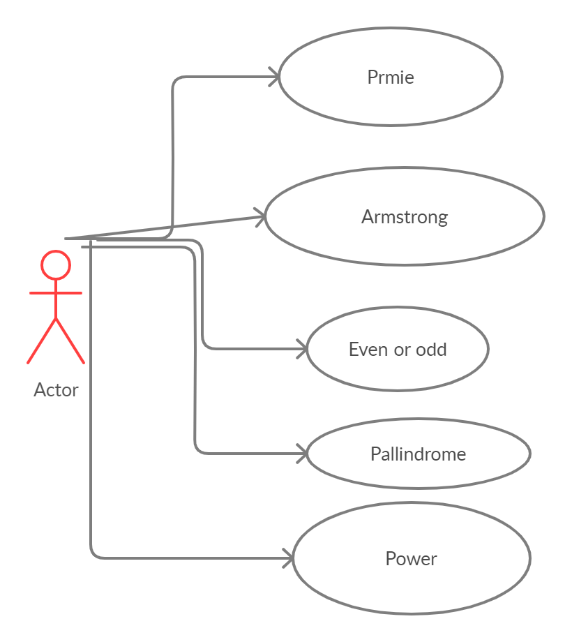

**3.2 Class Diagram**

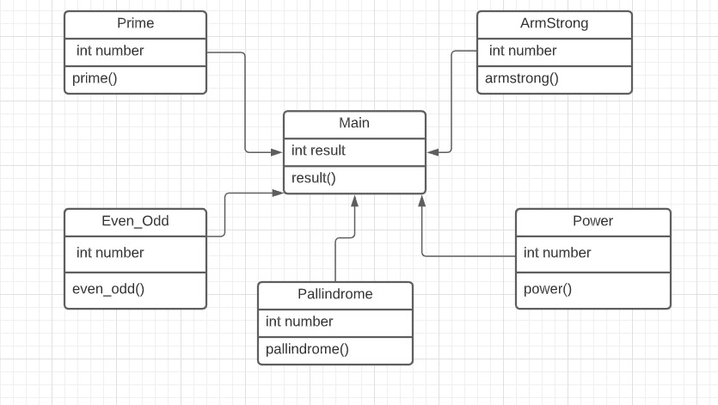

**3.3 Flow Chart**

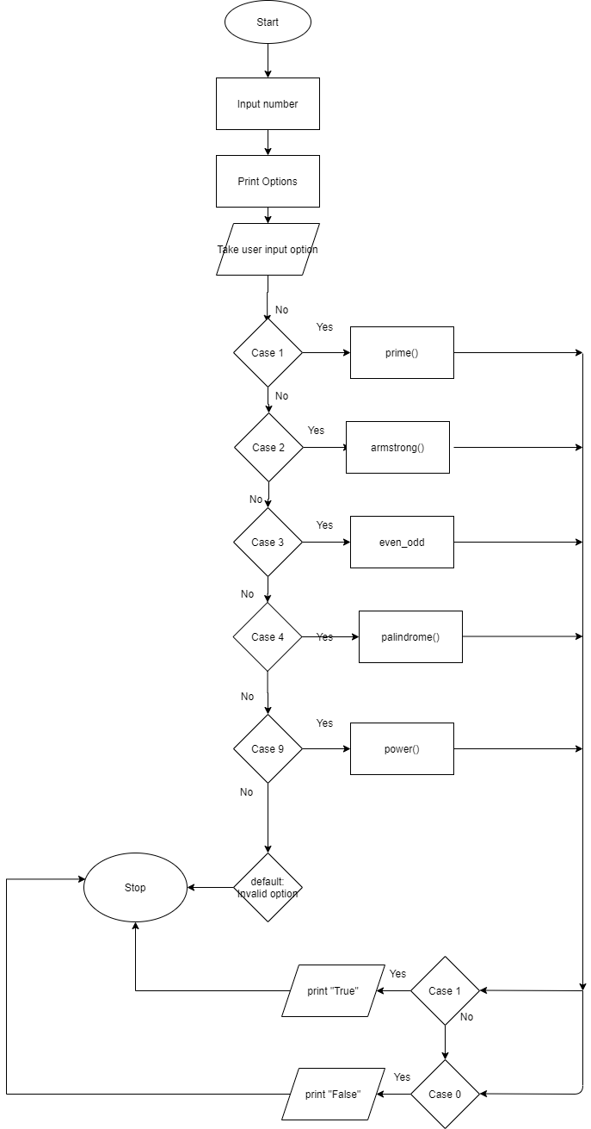

**3.4 Package Diagram**

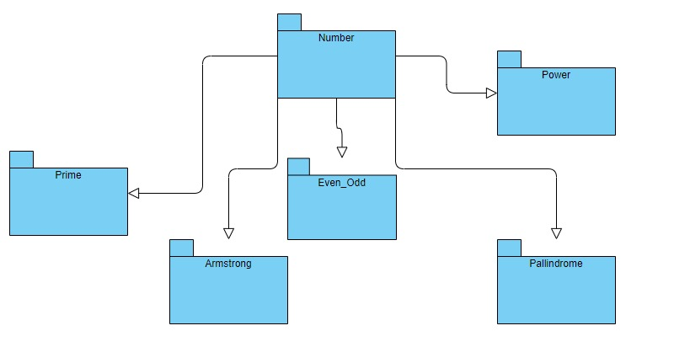

**4.Test Plan**

### 4.1 High Level Test Plan

|  |  |  |  |  |  |
| --- | --- | --- | --- | --- | --- |
| **ID** | **Description** | **Pre-Condition** | **Expected input** | **Expected Output** | **Actual output** |
| H01_T01 | To test properties of numbers | Input number must be positive | Some real number | True or False |  |
| H02_T02 | To do various operations with numbers | Input numbers must be positive | Some real number | Result of expression |  |

**4.2 Low Level Test Plan**

|  |  |  |  |  |  |
| --- | --- | --- | --- | --- | --- |
| **ID** | **Description** | **Pre-Condition** | **Expected input** | **Expected Output** | **Actual output** |
| H01_L01_T01 | To check whether a number is prime | A number is taken as input | Some real number | True or False |  |
| H01_L02_T02 | To check whether a number is Armstrong | Input number must be positive | Some number | True or False |  |
| H01_L02_T03 | To check whether a number is palindrome | Input number must be positive | Some number | True or False |  |
| H01_L03_T04 | To check whether given number is power of two | Input number must be positive | Some number | True or False |  |
| H01_L04_T05 | To check whether given number is even or odd | Input number must be positive | Some number | True or False |  |

**5. CI Work Flowing**

**5.1 GitHub Link**: https://github.com/stepin105012/SDLC

**5.2 Build**

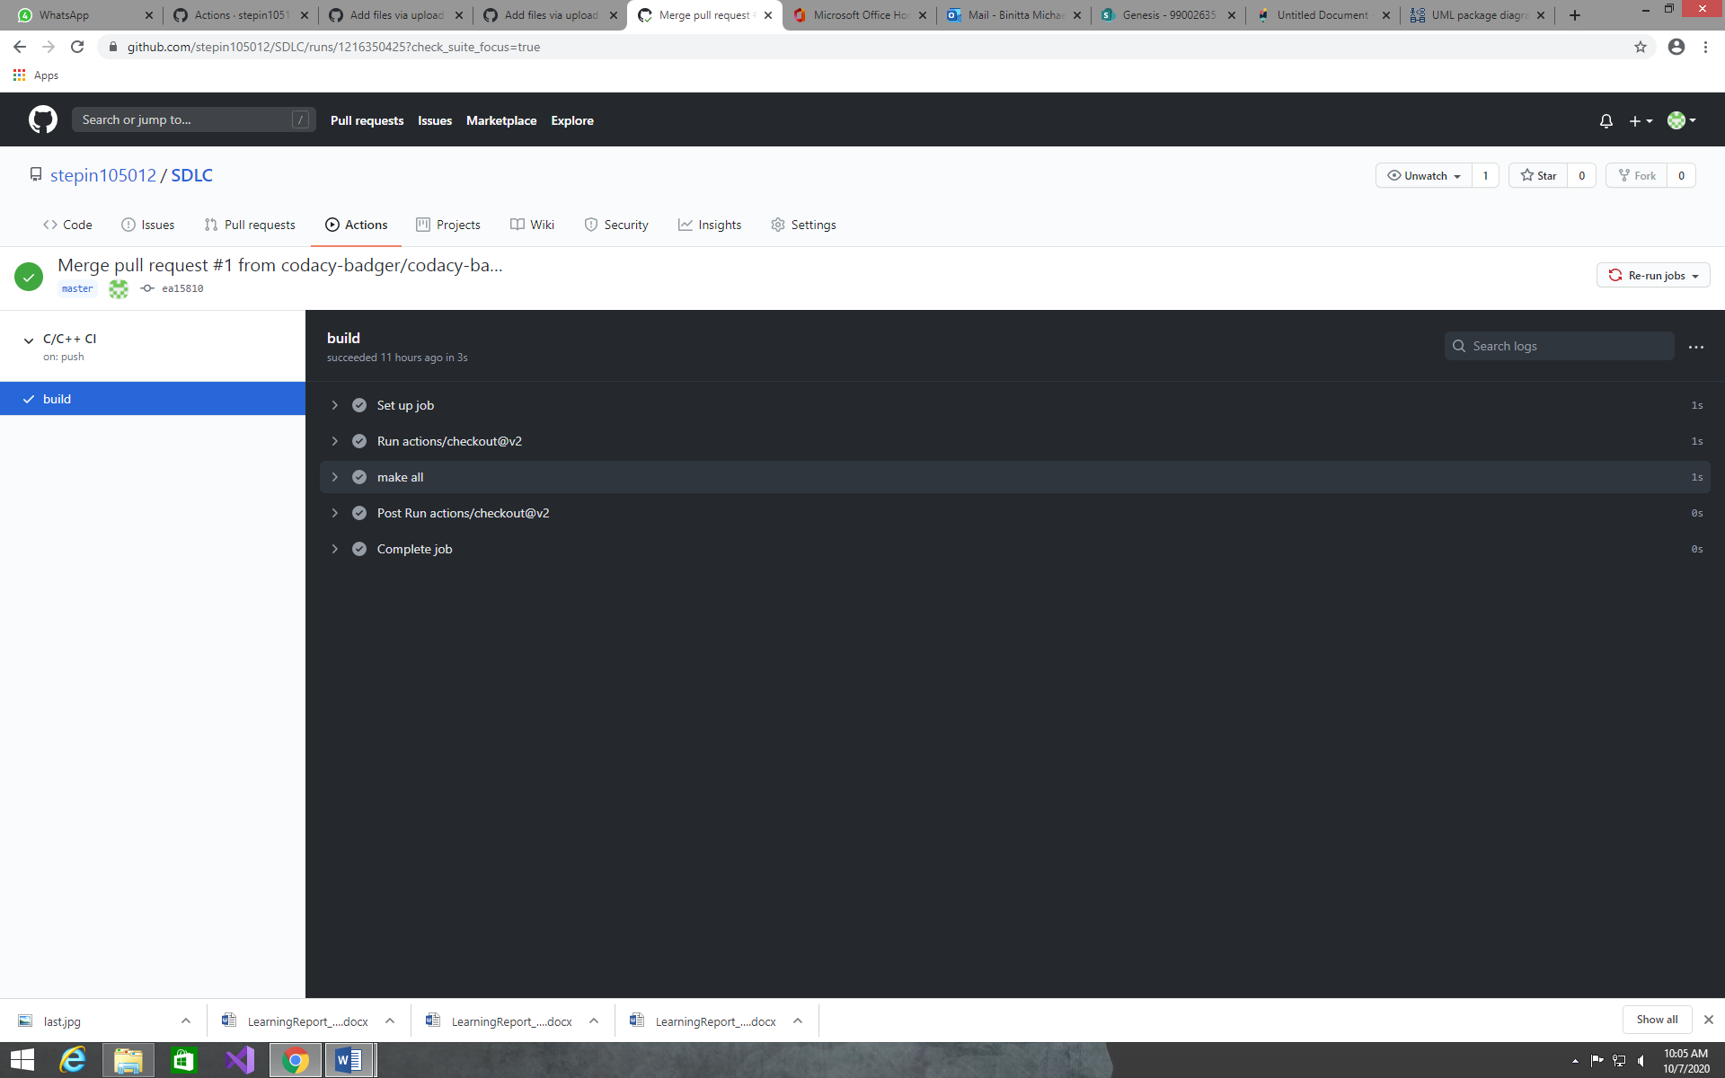

**5.3 Unit Testing**

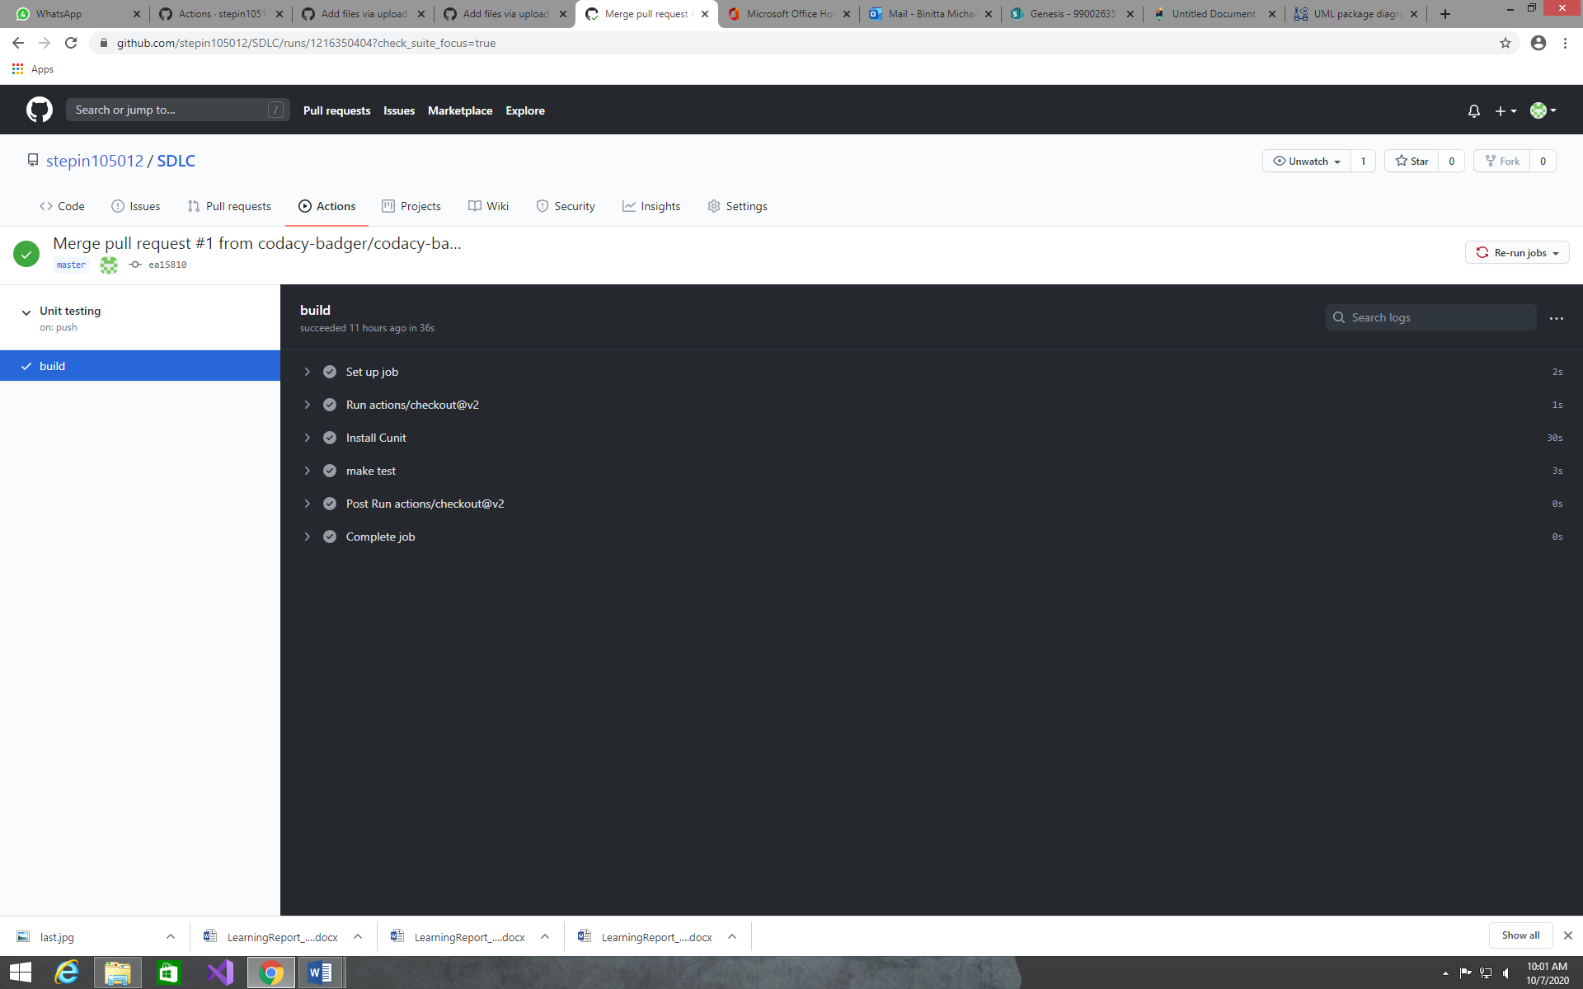

**5.4 CPP Check**

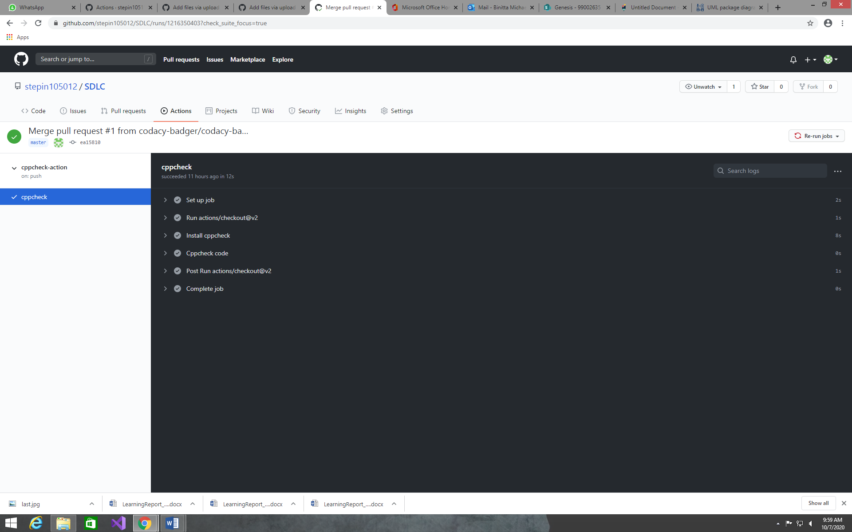

**5.5 Badges**

